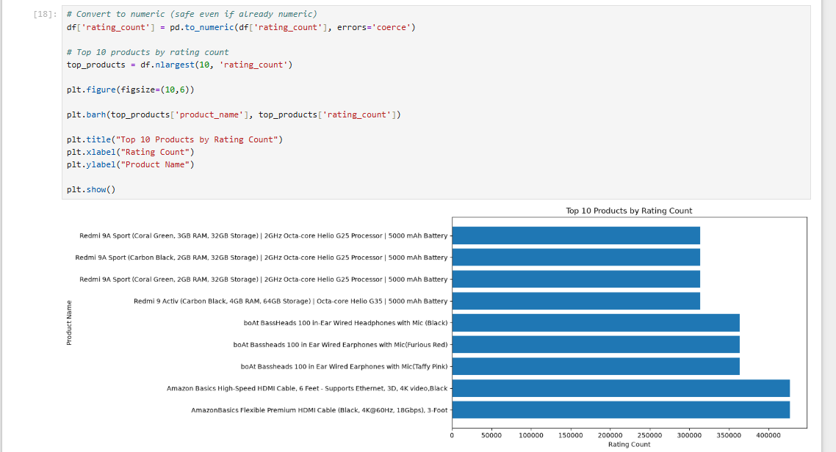

Horizontal Bar Chart – Top 10 Products by Rating Count

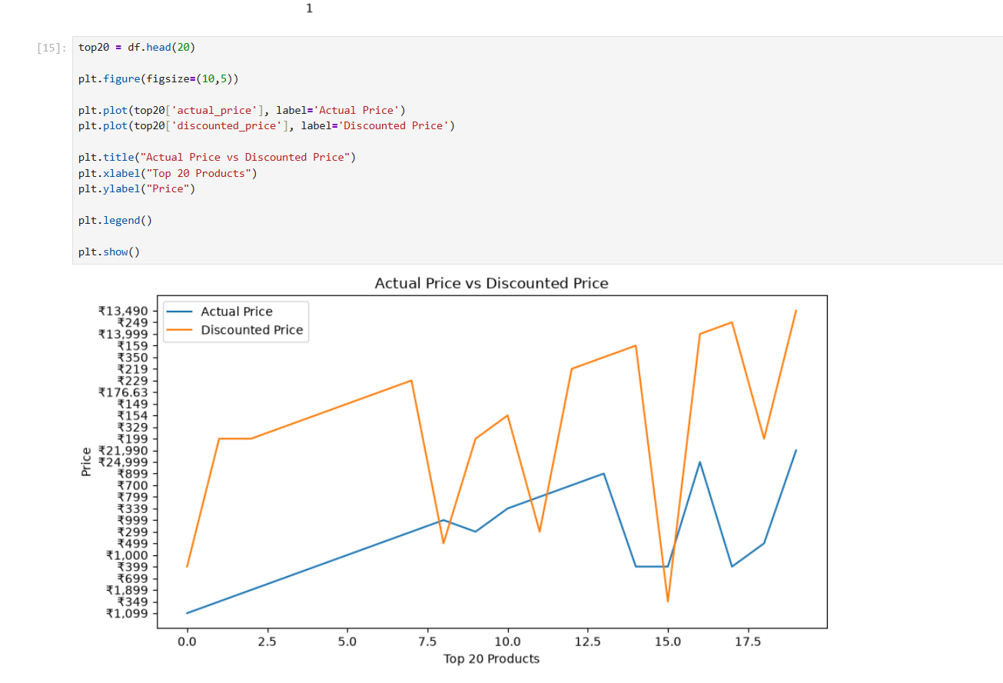

Line Chart – Actual Price vs Discounted Price

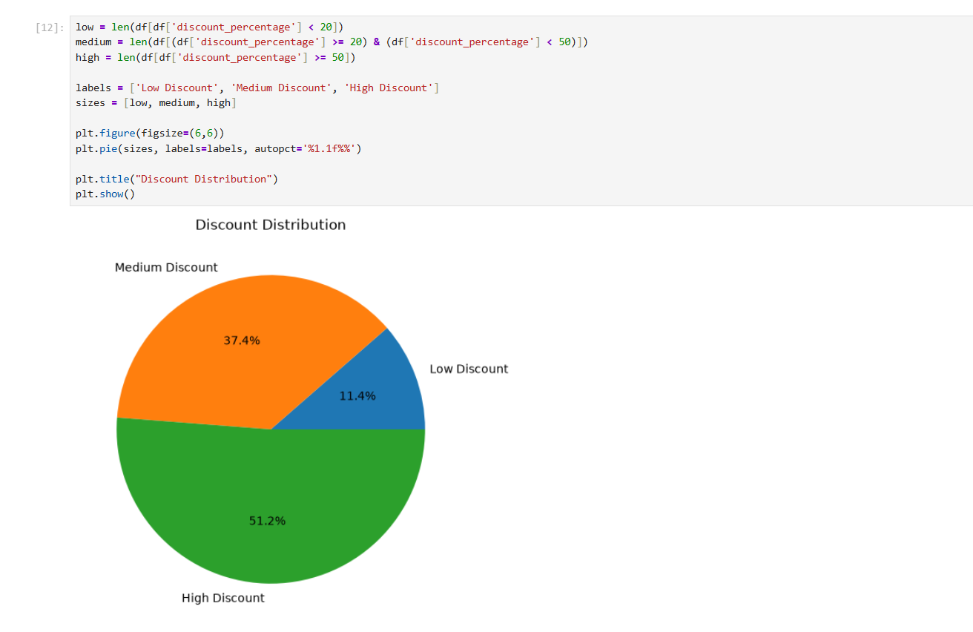

Pie Chart – Discount Distribution

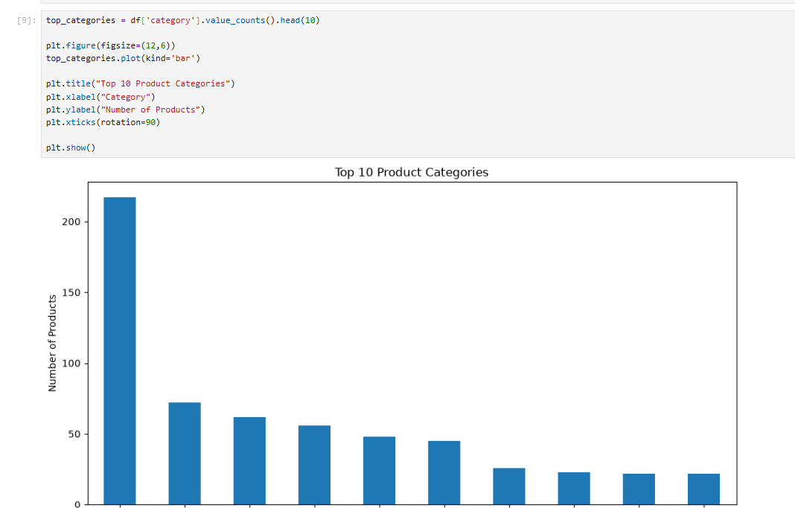

Bar Chart – Top 10 Product Categories

Histogram – Distribution of Product Ratings
